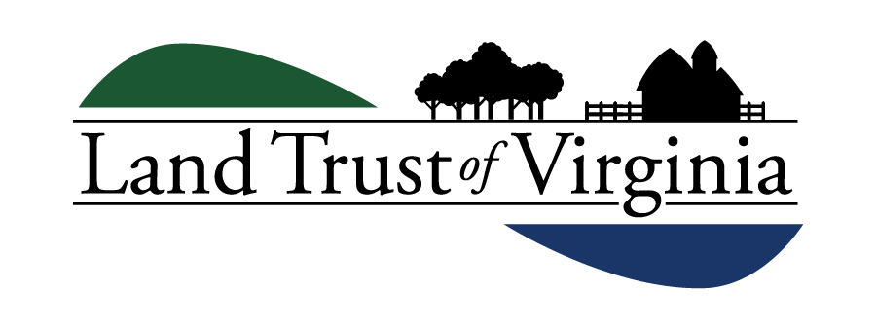

STOCK GIFT FORM FOR ELECTRONIC TRANSFERS

Please complete and email to ashton@landtrustva.org

For outright gifts/bequest gifts only - not for planned gifts

- Please instruct your broker to transfer DTC-eligible shares to the following account:
Bank: Wells Fargo Clearing Services – Jeanne M Campbell (703) 673-7044
DTC #: 0141
Account #: 7911-0564
Reference: Land Trust of Virginia – Stock Gift Account (Tax ID# 54-1601471)

- Important: You must notify the Land Trust of Virginia when you make a gift of stock. Your notification is the only way we can identify your gift when it is received. Please return this form using the instructions above, or call Ashton Cole at (540) 687-8441; email: ashton@landtrustva.org

- Upon confirming transfer, LTV will provide you with a formal tax receipt of your contribution.

THANK YOU FOR YOUR GIFT!

Date:

Who Owns Title to the Stock: ________________________________________

Donor(s) Name:

Address:

Phone: Email:

Name of Stock:

Number of Shares: Approximate Value:

Have you owned these shares for at least one year?

Delivering bank or brokerage and DTC:

Broker Name and Phone Number:

